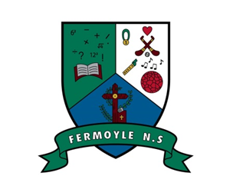

CALENDAR YEAR 2023/2024

Term 1:
- School re-opens on Tuesday August 29th – Finish 12 noon.
- Mid-Term Break: Monday 30th October to Friday 3rd Nov inclusive
- Christmas holidays: Closing on Fri 22nd December – 12 noon.
- Re-opening Monday 8th Jan

Term 2:
- St. Bridget’s Bank Hol Monday 5th Feb
- February Mid-term: Closed Thursday & Friday 15th & 16th Feb inclusive
- St. Patrick’s Day: Closed Monday 18th March
- Easter: Closing on Friday 22nd March – 12 Noon
- Re-opening Monday April 8th

Term 3:
- May Bank Holiday- Closed Monday May 6th & Tues May 7th
- June Bank holiday- Closed Monday June 3rd
- Summer Holidays – Closing Friday June 21st – 12 noon.

