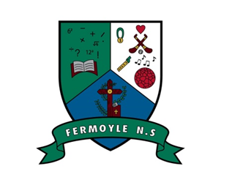

CALENDAR YEAR 2024/2025

Term 1:
- School re-opens on Wednesday 28th August – Finish 12 noon.
- Mid-Term Break: Monday 28th October to Friday 1st Nov inclusive
- Christmas holidays: Closing on Fri 20th December – 12 noon.
- Re-opening Monday 6th Jan

Term 2:
- St. Bridget’s Bank Hol Monday 3rd Feb
- February Mid-term: Closed Thursday & Friday 20th & 21st Feb inclusive
- St. Patrick’s Day: Closed Monday 17th March
- Easter: Closing on Friday 11th April – 12 Noon
- Re-opening Monday April 28th

Term 3:
- May Bank Holiday- Closed Monday May 5th
- June Bank holiday- Closed Monday June 2nd
- Summer Holidays – Closing Friday June 20th – 12 noon.

